**Test Summary Report**  
**Platform**: PhotoPrism  
**Feature**: Photo Search and Filtering  
**Test Plan Identifier**: TP002 - Automation Test Plan - v1.0 - Draft  
**Prepared By**: Haya Hussien  
**Date**: [19th January 2025]

**Summary**

* Automation testing for Photo Search and Filtering features completed successfully.
* **UI Tests**: 11 test cases executed and all passed.
* **API Tests**: All 9 test cases executed and all passed.

**Metrics Collected**

* **Number of defects identified**: 0 defects identified during testing.
* **Test coverage**: 100% of planned test cases executed.

**Lighthouse Metrics:**

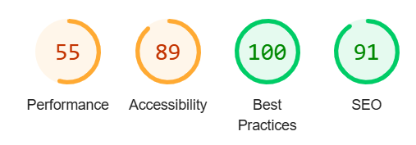

**Conclusion:**

Overall, the platform is stable. No bugs or defects were identified during testing.